We would like to thank all reviewers for careful reading, helpful comments, and constructive suggestions, which have significantly improved the presentation of our manuscript.
We have carefully considered all comments from the reviewers and revised our manuscript accordingly. We summarize our responses to each comment from the reviewers. We believe that our responses have well addressed all concerns from the reviewers. We hope our revised manuscript can be accepted for publication.

Reviewer #4:
1. Lines 7 to 16: The authors intend to introduce several segmentation algorithms for distress. However, in the field of computer vision, distress segmentation does not need to be based on distress classification. An instance segmentation task can accomplish both object classification and segmentation simultaneously. Please refine the wording here accordingly, or alternatively cite literature on distress instance segmentation.
Thanks for your comment. We agree that in current computer vision, distress segmentation does not necessarily depend on a prior distress classification step. To address this, we have revised both the caption of Figure 1 and the corresponding description in the manuscript. Specifically, we now clarify that Path (b) can involve a direct instance segmentation approach that simultaneously performs object detection or classification, and segmentation.
We added the sentence “Path(b) can also use a direct instance segmentation approach that simultaneously performs object detection, classification, and segmentation [19].” And cited recent studies that demonstrate the application of instance segmentation in pavement distress analysis: Fang et al. (2020) Automation in Construction.

2.In Equation (3), why is "+1" added after the prediction result y^? Is it to avoid a zero numerator? Additionally, why is y^+1 square-rooted? Is it to give greater weight when
y^ is small? It is recommended to explain the modifications made to PCILoss in more detail to improve comprehensibility.
Thanks for pointing this out. (1) The “+1” term is introduced to prevent division by zero when the predicted PCI (ŷ) is close to zero. Since PCI values can be as low as zero in distressed pavement sections, this small offset ensures numerical stability during training.
(2) The square root of (ŷ + 1) is applied as a scaling factor to adjust the penalty distribution. Specifically, this design increases the relative penalty for errors when the predicted PCI value is small, thereby encouraging the model to focus more on low-PCI pavement units (which are more critical for maintenance decisions).
We deleted the “This weighting mechanism increases the penalty for errors in predicting lower PCI values, thus focusing the model’s learning more significantly on these critical sections.” And add “The “+1” term is introduced to prevent division by zero since PCI values can be as low as zero in distressed pavement sections, this small offset ensures numerical stability during training. The square root of (ŷ + 1) is applied as a scaling factor to adjust the penalty distribution. Specifically, this design increases the relative penalty for errors when the predicted PCI value is small, thereby encouraging the model to focus more on low-PCI pavement units (which are more critical for maintenance decisions).” In section 2.1.

3.The size of the PCI-Block is sometimes (3×3) and sometimes (5×5), and no obvious regularity is observed. Please explain in detail the selection criteria for the two PCI-Block sizes and the structural differences.
Thanks for your careful check. The choice between using a 3×3 convolution kernel or a 5×5 convolution kernel in the PCI-Block was intentional and based on balancing feature extraction granularity and computational efficiency. 3×3 kernels are widely adopted in CNN design (e.g., VGGNet, ResNet) because they provide efficient local feature extraction with fewer parameters. In PCINet, 3×3 kernels capture fine-grained local details of pavement distress patterns, such as small or localized defects. 5×5 kernels, on the other hand, have a larger receptive field. We selectively introduced them in deeper layers of the PCI-Block to capture broader contextual information, such as the overall shape or spread of alligator cracks and potholes, which cannot be fully represented by smaller kernels. The combination of 3×3 and 5×5 kernels allows the network to learn both localized and contextual distress features. This mixed strategy improves robustness across different distress types. Structurally, both PCI-Blocks maintain the same pipeline of convolution → batch normalization → activation, but differ only in the convolution kernel size. We have revised the Methods section (Section 2.3) by adding: “In the PCI-Block design, both 3×3 and 5×5 convolution kernels are employed to balance local detail extraction and broader contextual understanding. The 3×3 kernels serve as the default choice due to their efficiency in capturing fine-grained features such as small cracks and localized pavement irregularities, while maintaining a relatively low parameter count. In contrast, the 5×5 kernels are selectively applied in deeper layers to expand the receptive field and capture more global structural patterns, such as the spread of alligator cracking or the extent of pothole areas. Structurally, both kernel types follow the same convolution–batch normalization–activation sequence, differing only in their kernel size. This hybrid configuration allows PCINet to learn complementary information at different spatial scales, improving its robustness across diverse distress types without introducing excessive computational complexity.”
4.PCINet applies a sigmoid function after the Linear layer. How does such a network structure achieve PCI regression? How is the sigmoid output mapped to the PCI range of 0-100? It is recommended to provide an explanation and supplement this part.
We thank the reviewer for highlighting this point. Specifically, the sigmoid activation is used to ensure that the network output remains bounded between 0 and 1, which stabilizes training and avoids unrealistic predictions outside the valid PCI domain. During post-processing, the normalized prediction is rescaled back to the original PCI range by multiplying by 100, thereby yielding PCI estimates between 0 and 100. This design ensures that regression is achieved while maintaining consistency with the scale of PCI values. The corresponding clarification has been added to Section 2.3.

5.The authors introduce DenseNet, ResNet, YOLOv8, and MobileNet as comparisons in the experiments. However, YOLOv8 is an object detection network—please explain how it was applied to the PCI regression task.
We thank the reviewer for this valuable comment. While YOLOv8 is indeed designed for object detection, in this study we repurposed it as a classification model for PCI prediction. Specifically, we removed the detection head and modified the final output layer into a 101-class classifier, where each class corresponds to a PCI value from 0 to 100. This allowed YOLOv8 to predict the most likely PCI class for each pavement image, making it comparable with other baseline classification networks (ResNet, DenseNet, MobileNet). We have clarified this adaptation in the Methods section to avoid confusion.
Reviewer #5:
This manuscript proposed PCINet, a CNN-based regression model for directly predicting the Pavement Condition Index (PCI) from pavement images, incorporating a customized loss and evaluation metric. However, the manuscript would benefit from additional clarification on the data acquisition setup, the model's adaptability to different imaging conditions, and a more comprehensive discussion of generalization and reproducibility.
1. The manuscript does not clearly describe the data acquisition procedure used in this study, including the type of equipment, mounting position, shooting height and angle, acquisition speed, and environmental conditions. These factors directly influence the characteristics of the images and may affect the applicability and performance of PCInet. Furthermore, it is unclear whether PCInet is specifically designed for a certain acquisition setup, and how well it generalizes when acquisition conditions change, such as variations in resolution, viewing angle, illumination, or shooting distance. It is recommended that the authors provide detailed information on the acquisition conditions in the methodology section, and analyze PCInet's performance and adaptability under different acquisition scenarios in the experiments or discussion.
Thank you for your valuable comment. The pavement image dataset used in this study was collected by the Federal Highway Administration (FHWA) in collaboration with the University of Missouri and the University of New Hampshire. We obtained this dataset through the FHWA student competition, Data Science for Pavement Symposium (DSPS). Each image has a resolution of 1536×1536 pixels. However, detailed acquisition information such as the type of equipment, mounting position, shooting height and angle, acquisition speed, and environmental conditions was not provided. We acknowledge that these factors are definitely important for image regression tasks, as they directly influence image quality and model performance.
The PCI labels for the images were annotated by FHWA experts and provided as ground-truth references. According to the dataset description: “This is the third DSPS student competition on the application of AI for pavement condition monitoring. Participants will use novel machine learning algorithms to predict the pavement condition index (PCI) for road sections based on images captured from infrastructure-mounted sensors. Training datasets provided consist of top-down views of pavement images and associated pavement condition index.” The dataset covers pavement sections located in the Washington, D.C. area, as illustrated in the provided map.
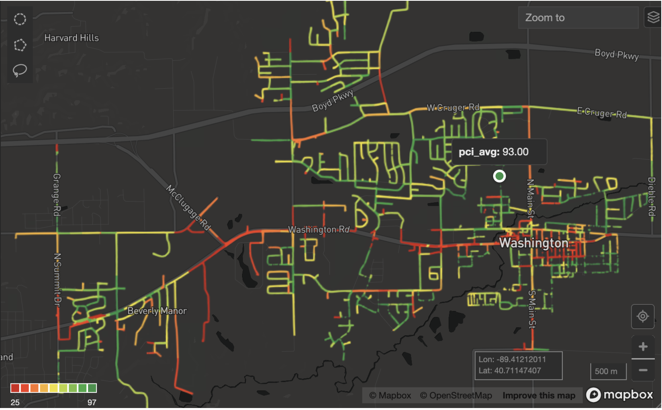
For reference, the dataset is publicly available at: https://github.com/UM-Titan/DSPS24, and more details can be found on the DSPS24 competition website: https://dsps-1e998.web.app/.
We fully agree with the reviewer that variations in resolution, viewing angle, illumination, and shooting distance are significant parameters that can impact both image characteristics and the performance of PCINet. Unfortunately, aligning PCI labels with additional acquisition metadata requires substantial effort and domain expertise, and currently no other open-source datasets are available for PCI prediction from images. To address this limitation, we have added a discussion in the revised manuscript: “
4. DISCUSSION
Although PCINet demonstrates promising performance on the DSPS24 dataset, several limitations remain regarding data acquisition and model generalization. The dataset was collected using infrastructure-mounted cameras in the Washington, D.C. area, but detailed acquisition metadata such as mounting height, camera type, shooting angle, acquisition speed, and illumination conditions were not provided. These factors directly influence the visual characteristics of pavement images and may affect the reproducibility of results when applying PCINet to other datasets or in real-world scenarios.
Variations in acquisition conditions, including differences in resolution, illumination, shooting distance, and viewing angle, can significantly impact the appearance of pavement distresses. For example, shadows, low-light environments, or oblique viewing angles may obscure cracks or alter their visual representation, potentially reducing the accuracy of PCI predictions. While PCINet is not tied to a single acquisition setup, retraining or fine-tuning would be necessary to ensure robust performance across diverse imaging conditions. Data augmentation strategies, such as random brightness adjustments, geometric transformations, and noise injection, can also be applied to improve model resilience against these variations.
Furthermore, the lack of publicly available datasets with paired PCI labels limits opportunities for broader benchmarking and reproducibility studies. Expanding the dataset to include images captured under different weather conditions, pavement types, and geographic regions would allow for more comprehensive validation of PCINet. Future research will therefore focus on collecting heterogeneous datasets and exploring transfer learning approaches to enhance model adaptability and generalization across diverse acquisition environments.”

